**Wind farm layout optimisation using a genetic algorithm**

Arif Malik, Bharath Shivamogga-Jairam, Ryan Shaw, Mingting Hong, Filip Tobolewski

**Abstract**

The 2015 GECCO competition presented an opportunity to apply evolutionary computation to solve a prevalent difficult problem in the field of wind farm optimisation. The computational complexity of modelling the wake effect on wind farm layouts is one issue plaguing the world of sustainable energy generation. In this report we demonstrate how applying various constraints on the representation of the problem, can yield good approximations for real world data. We focus on using the most pertinent data available to apply the maximum number of constraints, reducing complexity while maintaining a viable real-world result.

1. **Introduction**

The necessity of renewable sources of energy is paramount with our current climate crisis. By current estimates only around 27% of energy is from renewable sources (1). This issue will be further exacerbated by the growing energy needs, which are estimated to double by the near 2050 (2). In this report we will focus on developing a model for wind farm optimisation which is a fertile area of research with practical applications that are in demand. We begin with a brief overview of the problem, where we discuss the parameters and simplifications we use. Following this we discuss the literature available on the topic and the competition where this problem was first presented. In the method section we describe the solution to the problem we present, with explanations of our algorithm. We finally conclude with a discussion of our result.

The theoretical efficiency of wind turbines has long been known from the research undertaken by Albert Betz. The calculation below describes the theoretical limit on the extraction of power from a turbine. This calculation is based on conservation of mass and the limit we can achieve is 59.3% conversion rate from kinetic energy in the wind to electrical energy produced. An extension to this topic can be found in the form of the Navier-Stokes equation, which is beyond the scope of this report due to the simplifications we make.

$$P = \frac{16}{27}\frac{1}{2}ρv^{3}A=\frac{8}{27}ρv^{3}A$$

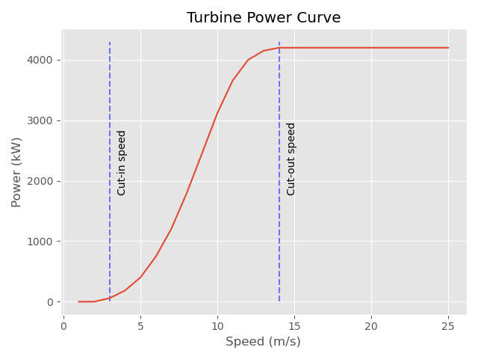We reduced the problem complexity by considering some simplifications that can be made. We do not consider the economic costs of installing and maintaining any farm design. We have a simplified the power yield of the wind turbines, using real world data for turbines while making a small change to the calculation. Our power curve calculation consists of an s-shaped curve, that plateaus to a value of the maximum power derived from the wind turbine. In reality, at extremely large wind speeds turbines would have to be shut down for safety reasons both to the public and the structural integrity of the turbine itself. The following plot is indicative of the power derived from the turbines at varying wind speeds:

Wake effect -

Reducing problem complexity by:

~~We do not consider costs of electrical cabling, step up and step down transformers, loss of power over distance~~

~~Power curve simplification – plateu at max power not go down at large wind speeds~~

Wind direction simplification – have 1 or 4 directions for wind (for 4 represents north south east west)

Farm – 12 x 12 matrix with 25 wind farms placed on it

Power yield = from power curve for wind speed data x power of turbine at velocity v, sum for all 25 turbines in the 144 matrix positions.

**Possible discussion further in introduction (could omit due to 4-page limit):**

1. **Literature review**

Paper 1 (overview of the original 2015 competition): https://www.sciencedirect.com/science/article/pii/S096014811830363X

In the original competition, we are presented with minimising the cost function which considers many parameters that have an impact on the economic viability of a wind farm. The authors also reward solutions with high number of turbines, to counteract the possibility of small layouts having good theoretical efficiencies but poor power outputs. Across all the different scenarios, the 3-stages memetic differential evolution (3s-MDE) approach proved to produce the best results, outperforming on four of five tested scenarios. This approach creates a surrogate model that creates a candidate solution, which is evaluated by the fitness function, starting with two initial turbines on the first instance. A range of predetermined distances between turbines is considered to calculate the effect of adding additional turbines to the solution, as their presence will influence the power generated. This method provided significant improvements, especially compared to the GA described in the paper. When considering standard methods of optimising placement of each individual turbine placement the competition results presented provide a superior method of solving for this complex problem.

Paper 2: <https://iopscience.iop.org/article/10.1088/1742-6596/1037/4/042012> (the paper for the gaussian wake)

In the following paper we are presented with a representation of the wake effect. The wake effect has a large influence the total energy production from wind farms. This is due to changes in wind speed as wind interacts with a turbine. While the flow of wind over a turbine occurs, perturbations and changes in direction of the wind occur. These perturbations have a significant impact on the ability of turbines downstream to collect wind energy. Wind turbines already have an inbuild theoretical limit on collecting the kinetic energy from wind and turning it to useful electricity, in the form of Betz’s Law. The authors propose a way to calculate this effect in equation [6]. The influence of this paper can be seen in our GaussianWake function in the WindFlo API, which provides a representation of this calculation.

Paper 3 (may not include due to 4 page limit for this report):

Possibly paper 4 (may not include due to 4 page limit for this report)

1. **Method**
2. **Conclusion**

**References**

References to be done properly later when we decide what to keep and what to remove, for now just links to the material:

Betz law: <https://en.wikipedia.org/wiki/Betz%27s_law> (find a proper reference for it)

1. <https://www.iea.org/fuels-and-technologies/renewables> 27% renewable energy
2. https://www.eia.gov/todayinenergy/detail.php?id=41433